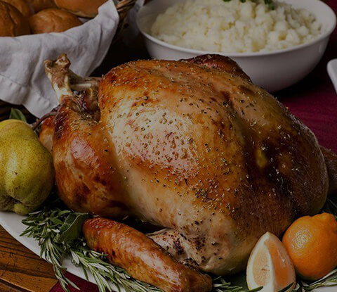
Citrus Brined Roasted Turkey
The Ingredients
For 8 Persons

1 whole thawed turkey
3 oranges (wedged)
3 lemons (wedged)

Compound Butter Ingredients
1.5 cups softened unsalted butter
3 tbsp chopped fresh rosemary
1 tbsp orange zest
1 tbsp lemon zest
1 tbsp lime zest
Kosher salt and fresh ground pepper to taste

Brine Ingredients
4 cups orange juice
0.25 cup lemon juice
0.25 sup lime juice
0.5 cup cup honey
1 cup brown sugar
2 cups coarse kosher salt
2 tbsp pickling spice* (see notes)
0.25 cup italian parsley
2 sprigs fresh rosemary
4 cloves crushed garlic
3 leaves fresh sage
1 whole orange peel
1 whole lemon peel
1 whole lime peel
1 gallon water

BRINING INSTRUCTIONS
- Combine ingredients in a large pot and bring to a boil.
- Remove from the heat, cover and allow to cool for 45 minutes. Add enough ice to the pot to create 2 gallons of brine mixture and stir until most or all the ice has melted.
- Place the turkey in a large plastic bag or food safe bucket. Add the brine mixture. Refrigerate 12-24 hours

COMPOUND BUTTER INSTRUCTIONS
- In a large mixing bowl, mix the ingredients thoroughly.
- Place the mixture on a large piece of clear plastic wrap. Form the mixture into a long “log like” roll and wrap in the plastic wrap. Refrigerate.

TURKEY INSTRUCTIONS
- Remove the turkey from the brine. Rinse and pat dry.
- Remove the compound butter from the refrigerator and allow it to soften.
- Insert the orange, lemon and lime wedges into the cavity of the turkey.
- “Truss” the turkey with butchers string or tie the legs together. Rub the compound butter over all the skin areas of the turkey.

Cooking Instructions
- Fill the grill with charcoal, light it and heat to 250°F (120°C). Add wood chunks (optional).
- Insert the heat deflector racks and plates. Place a drip pan on top of the plates and insert the main cooking grates.
- Place the turkey on the main cooking grates (roast for 2 hours).
- Increase the temperature to 350°F (175°C) and baste with more compound butter. Baste each hour of cooking. If the skin is becoming too dark you can tent it with aluminum foil.
- Target Internal Temperatures: 165°F (74°C) for the breast, 185°F (85°C) for the thigh.
- When done, remove from the grill and allow it to rest uncovered for 20-30 minutes.

Recipe Notes

OPTION: ROASTING BY TIME INSTEAD OF INTERNAL TEMPERATURE
If you do not have a pen thermometer or a way to check the internal temperature you can cook by time. Roast at 325°F (163°C) for 15 minutes per pound (For example: a 20 lb turkey should be roasted for 5 hours).
*A crushed mix of all spice, mustard seed, coriander, cloves, crushed red pepper, bay leaf

