Garlic and Cheese Crostini Gourmet | October 2009
From Gourmet Today cookbook
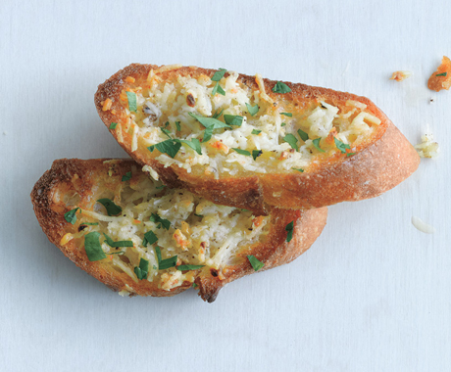
(photo by: Romulo Yanes)
These toasts are topped with a light sprinkling of minced garlic, olive oil, and sharp Pecorino Romano before being baked. Garlicky and salty, they are a great accompaniment to cocktails.
Yield: Makes 24 hors d'Oeuvres
Active Time: 20 min
Total Time: 30 min
24 (1/3-inch-thick) baguette slices (from a baguette at least
1/4 cup olive oil, divided
3/4 cup finely grated Pecorino Romano (preferably imported)
5 large garlic cloves, minced
Kosher salt
2 tablespoons finely chopped flat-leaf parsley
Preheat oven to 350°F with rack in middle.
Arrange bread slices in 1 layer on a large baking sheet and brush tops with 3 tablespoons oil.
Stir together remaining tablespoon oil, cheese, garlic, 1/4 teaspoon kosher salt, and 1/4 teaspoon pepper in a small bowl. Sprinkle each slice with about 1 teaspoon cheese mixture, mounding it slightly.
Bake until topping just starts to melt, 6 to 8 minutes. Sprinkle with parsley and kosher salt to taste. Serve warm.
Cooks' Note:
Cheese mixture can be made 1 day ahead and chilled.

