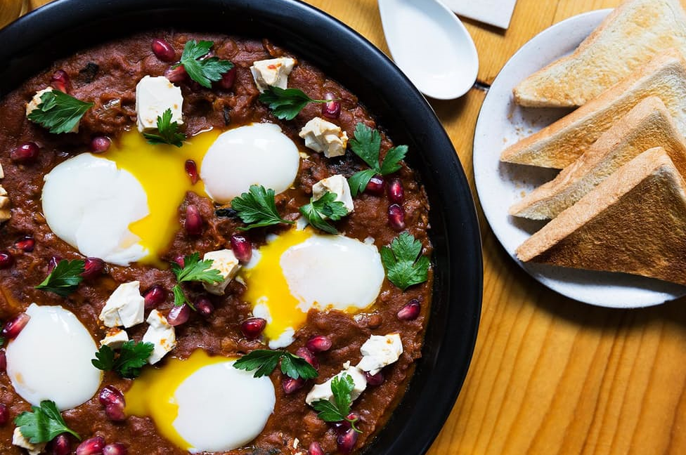Japanese Shakshuka
Recipe adapted from Emily Yuen, Bessou, New York, NY
Yield: 4 servings
Prep Time: 20 minutes, plus 2 days pressing and marinating time
Cook Time: 40 minutes
Total Time: 1 hour, plus 2 days pressing and marinating time
If you love shakshuka as much as we do, pay attention. In this recipe from Bessou in NYC, Japanese curry powder and roast kabocha squash add spice and texture to a roux-thickened tomato sauce. Poached eggs are nestled on top, so you can go to town dipping toasted milk bread into this rich and hearty breakfast, perfect for the cold weather.
The tofu labneh is one of our favorite parts of this recipe. With the liquid pressed out, the firm tofu is slathered with red miso for a salty richness that's similar in texture and flavor to feta cheese. If you’ve been looking for a vegan cheese, your search just might end here.
Ingredients  For the Tofu Labneh:  One 14-ounce package extra-firm tofu  ¼ cup red miso  For the Roast Kabocha Squash:  ¼ medium (10 ounces) kabocha squash, seeded and flesh cut into ½-inch wedges  2 tablespoons olive oil, divided  Kosher salt, to taste  For the Shakshuka:  2 tablespoons olive oil  1 yellow onion, thinly sliced  8 garlic cloves, minced  One 1-inch piece ginger, peeled and finely grated  2 tablespoons unsalted butter  2 tablespoons all-purpose flour  ¼ cup Japanese curry powder  2 tablespoons harissa paste  2 teaspoons ground cumin  4 cups crushed tomatoes  Kosher salt, to taste  5 poached eggs, for serving  Pomegranate seeds, for garnish  Parsley leaves, for garnish  Toasted milk bread, for serving | Directions  1. Make the tofu labneh: Wrap the tofu in cheesecloth and place between 2 plates. Set a light weight, such as a large can, on top of the plates to weigh down the tofu and press out the water. Refrigerate overnight.  2. The next day, unwrap the tofu and slather it with the miso. Let marinate in the refrigerator for at least 1 day, or up to 1 week. Scrape off the excess miso, then crumble and set aside.  3. Make the squash: Preheat the oven to 450°. On a sheet pan, toss the squash wedges with the olive oil and salt. Roast until golden brown and tender, 15 to 20 minutes. Remove the skin and cut into large chunks, then set aside.  4. Make the shakshuka: In a 4-quart Dutch oven, heat the olive oil over medium heat. Add the onions and sweat until softened, 8 to 10 minutes. Add the garlic and ginger, and cook until fragrant, 2 minutes.  5. Add the butter and melt, then stir in the flour until incorporated and cook for 2 minutes. Add the curry powder, harissa and cumin, stirring to incorporate.  6. Add the crushed tomatoes and bring to a simmer. Cook, stirring often, until thickened, 10 to 12 minutes. Season with salt.  7. Stir in the roast squash and cook until warmed through, 2 minutes more. Remove from the heat and make 5 wells in the sauce. Add a poached egg to each well, then garnish with tofu labneh, pomegranate seeds and parsley leaves. Serve with toasted milk bread.

